3rd grade Science Fair
April 1, 9-10:30am School Cafeteria

Science Fair takes places on Wednesday, April 10 from 9-10:30am. Third graders will complete a Science Fair project at home and then share their projects at school. During the month before the Science Fair, we will study the scientific method at school and complete some simple science experiments to demonstrate each step of the method. All students are expected to complete an experiment and display their results neatly on a display board (these are provided by the school and sent home one month prior to science fair). Students will receive a Science grade based on completion of the project, neatness, and ability to speak knowledgeably about what they did and the results of their experiment. Students will share their experiments with teachers and parents. Parents are invited to stop by and view all projects on the day of the fair from 9-10:30am.

***NO JUDGING IN THIRD GRADE

Keys to Science Fair Success:
1. Keep it simple and fun
2. Project should be based on student interest, easily available materials, and time permitted. Please do not recycle older sibling projects.
3. Plan ahead (use the schedule sent home in the newsletter)
4. Help your student keep it neat and organized
5. Practice! Practice! Present the project at home so student can communicate effectively about their project.
Note: Students may not bring food, living organisms, plants, toxins, sharp items or anything dangerous to school. Please use photos to display projects. Contact your teacher if you have questions.

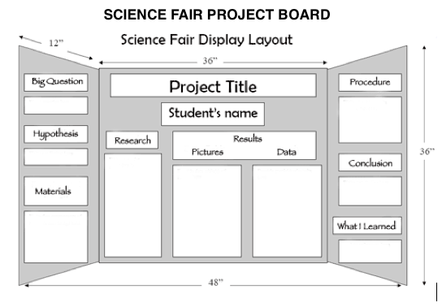
Resources for 3rd grade Science Fair

Granite’s Science Fair Instruction Booklet:
https://cdn-59bd6cf5f911c923e82ee0ee.closte.com/wp-content/uploads/sites/29/2014/11/Sci-Elementary-Science-Fair-Presentation.pdf

Science Fair Ideas:
http://www.sciencebuddies.org

https://www.education.com/science-fair/third-grade/

The Scientific Method should include:

1) The Question: What is that you are interested in studying? What are you trying to discover through your experiment or project?
2) A Hypothesis: What do you think will happen when you do your experiment?
3) Research: Gather information related to your question, you want to be able to discuss what it is you are studying
4) Experiment: Step by step instructions on what you did and how you did it.
5) Data: What information did you collect from the experiment?
6) Observations: What did you see happen?
7) Conclusion: Why do you think what happened in your experiment happened? Use your research and experiment findings to back up your conclusion.

Grading Rubric:

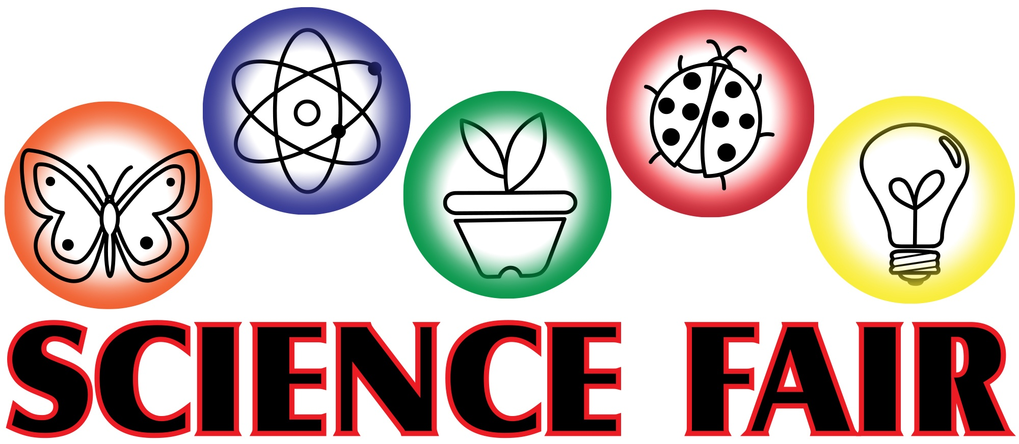
Name:______________________________________________________________________________________

Project:_____________________________________________________________________________________

Science Fair Rubric

Student completed a science project _______/25
Student utilized Scientific Method _______/25
Student’s board is neat, easy to read and creative _______/25
Presentation: Student is prepared and can speak about project _______/25

Total Points _______/100

