Multiplication Masters

Become a Master of Multiplication
By following these easy steps!

Memorize Your Math Facts
- Memorize the facts, you will. Memorize each fact starting with 2’s. Do not move on to the next fact until you have passed the 2’s quiz. Then work on 3’s. Pass them. Then 4’s. Etc. All the way to 12’s.
- Use flashcards, online games, songs, and skip counting. Whatever strategy works for you. Put flashcards in the car. Have mom quiz you on the way to dance or soccer or piano. Write them out multiple times. Print out your own quizzes. Put a multiplication APP on mom’s phone or your iPOD, iPAD or whatever device you have. Find programs and APP’s that allow you to practice one math fact at a time (do not practice all facts at one time until you pass all 12).
- Practice, practice. Practice verbally and practice on paper. Practice them in order and then practice them out of order. Practice until you have them automatically. Produce the fact within 3 seconds. If you don’t have it fast, you don’t have it yet.
- PRACTICE AT HOME, YOU MUST! At least 10 minutes per day, some students will need more.
- You’re ready to take the quiz if you can do 20 mixed up problems on paper in less than 1 minute.

Take A quiz
- There is a sample quiz on the back of this page so you can see what is expected.
- The quizzes are all 20 questions in 1 minute. There are 3 versions of each fact quiz, so if they need to repeat, they will not get the same exact quiz.
- Students must get 100% to pass off that fact. They receive a paper ribbon, choose a small prize and sign their name on the bulletin board under each passed fact.
- Quizzes are offered in class 2-3 times per week.
- Students may take each quiz as many times as it takes to pass.
- Each students works at their own pace. Parents will receive an update with student progress every few weeks.

Goals
- Students should pass off a minimum of 1 fact per week. All facts should be passed by Tuesday, January 31.
- Multiplication Masters: Students become a Multiplication Master when they pass off 12’s and they are then invited to our Pizza Party the first week of February.
- Once students pass off 12’s, they then work on passing off mixed facts. Students will be expected to pass off 40 mixed facts in 3 minutes and then 100 mixed facts in 5 minutes by then end of February.

May the force be with you!

Example quiz:

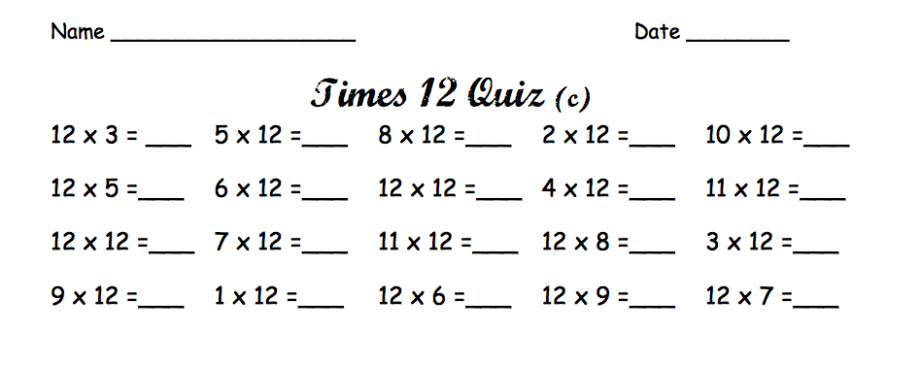
Resources:

Free Flashcards: See PDF attachment from Mrs. Duff (all students received a set at school)

Mrs. Duff’s Class Website: www.duff3.weebly.com
http://www.math-drills.com/multiplication.php
http://www.math-aids.com/Multiplication/Multiplication_Drills.html (make your own 1 minute worksheets)

Online games:

http://www.hoodamath.com/games/multiplication.html

Electronic flashcard/games: http://www.learninggamesforkids.com/math_multiplication_games.html

List of Apps and games to check out: http://www.edutopia.org/blog/10-apps-for-math-fluency-monica-burns

www.Multiplication.com (games, electronic flashcards)

Timezattack: you can still find this free for home use online if you google it (it became so popular it was bought out and now the company now only sells to schools at a hefty price). It is very fun and kids love it. Google and download the version for the type of computer you have at home. Be careful to avoid the free ads as you download- decline everything but the game.

